The impacts of the civil war on the African Forest Elephants in Liberia- U5503457
In December, 2009, there was an outbreak of civil war which commenced from a little border town-Liberia Ivory Coast and escalated throughout the entire country. This led to a massive exodus of the African elephants from the Ziama-Wenegisi corridor which includes the Ziama classified forest in Guinea and the Wenegisi national forest in Liberia, a bordering forest shared between Guinea and Liberia.Migration of elephants from Wenegisi to Ziama was noted during the war in Liberia, Sambola (2005). Conflicts and other anthropogenic activities for example, logging, illicit hunting, mining, urbanization, shifting cultivation are causes of wildlife extinction and or migration. (Afkinsider.com/threat-of –wildlife-extinction).
I was amazed when I watched this elephant migrating into Ziama forest in guinea live on the Guinean National television (action news) in 1996. The elephants form part of the features that make Liberia a biodiversity hotspot of conservation concern in West Africa. National park and other nature reserves have been established for the conservation and multiplication of these endangered species. National Parks of Liberia “Www. National-parks-worldwide.info/Liberia.htm”.

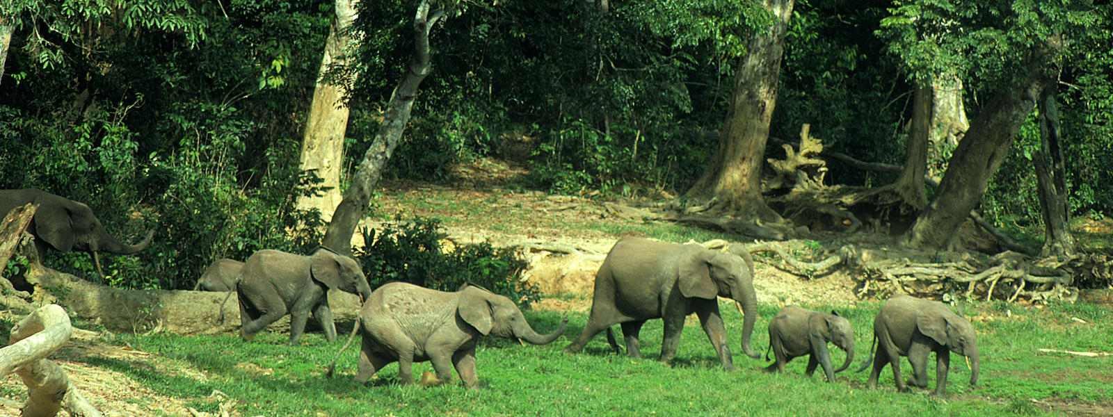
Figure 1 African elephants have less room to roam than ever before as civil war, poaching for bush meat and ivory increased proportionally with an increase in human population. Source: WWF: African elephant species. http://www.worldwidelife.org/species/forest-elephant.

Habitat loss
African elephants inhabit high rainforests and feed on non-timber forest products (NTFP), such as, nuts (e.g. makore and pentadesma seeds); forest vegetables (e.g. palm cabbage, flower bud of musanga tree commonly called cork wood). The huge falling sound of felled giant tropical rainforest trees (diameter 100-200 +cm), the power chain saws, bulldozers, earth moving equipment during the unprescribed logging operations led to habitat loss. Illicit hunting of elephants for bush meat and ivory/tusk by local people and foreign nationals as well as the sound of heavy artilleries contributed to elephant migration into the Ziama forest in Guinea. A significant area of habitat was destroyed due to the unprescribed logging operations carried out by the warlords as means of income to fuel the war. Consequently a massive exodus of elephants occurred. This was disastrous for Liberia, because elephants play a greater role in sustaining the ecosystem. They help propagate tropical rainforest trees like makore and others, these trees’ seeds can only germinate by passing through the elephants’ digestive track, these seeds germinate directly from the elephant dunk.

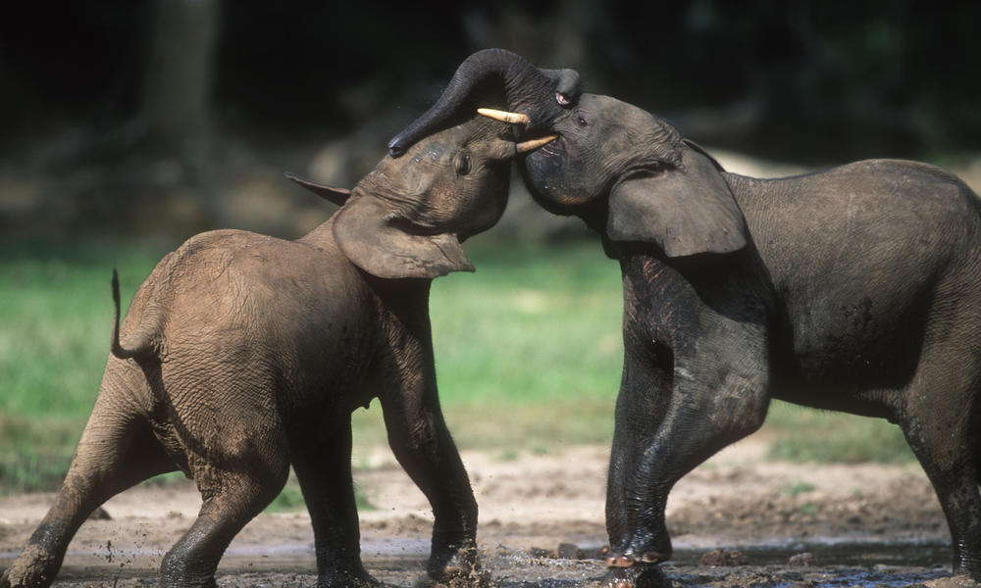
Figure 2 Elephants are found in dense forest and are essential for the germination of many rainforest trees. These seeds germinate after passing through the elephant’s digestive track. Source: http://www.worldwidelife.org/species/forest-elephant “WWF: African forest elephant species

The effects of elephant exodus
Human-elephant divergence is one of the key challenges noted by local services in the area of elephant management. Human-elephant conflict originates from crop looting by elephants. During the migration of elephants into the Ziama forest in Guinea, they raided all crops in the villages and towns located around and within the migrating corridor. That was a disaster for the locals in Guinea, but on the other hand, elephants propagated some trees species seeds in the Ziama forest. Ecologically, the species composition of the ziama forest improved and the elephant population increased for Guinea. While Liberia on the other hand lost huge population of elephant.
It is about time that every Liberian be conscious about the role elephants play in the provision of the ecosystem services, by exhibiting a high sense of conservation responsibility to maintain the natural heritage (elephant).
References
Afkinsider.com/threat-of-wildlife-extinction.

Sambola, 2005. Action Plan for the management of elephants in the Ziama-Wenegisi Trans frontier Corridor. IUCN- ‘The world Conservation, 2006’

www.National –Parks-worldwide.info/Liberia.htm: www.African Elephant Species
http://www.worldwidelife/forest-elephant.

